Pass for level 16: WaIHEacj63wnNIBROHeqi3p9t0m5nhmh

Step 1:Login to natas 15

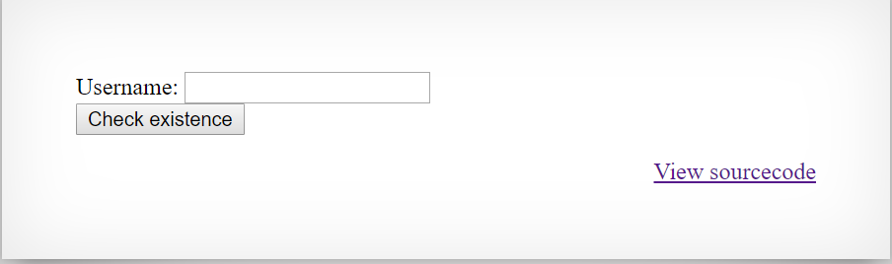

Step 2: View source code

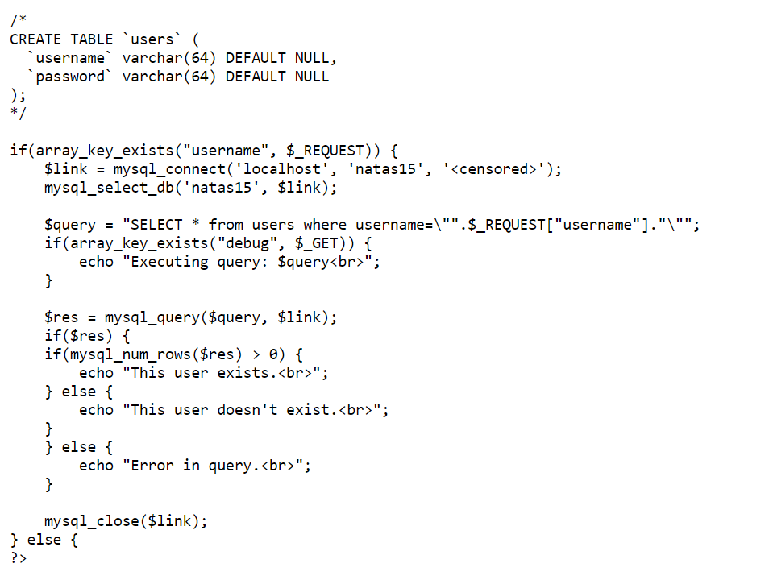

Step 3:

When I tried to write username = natas16 I get:

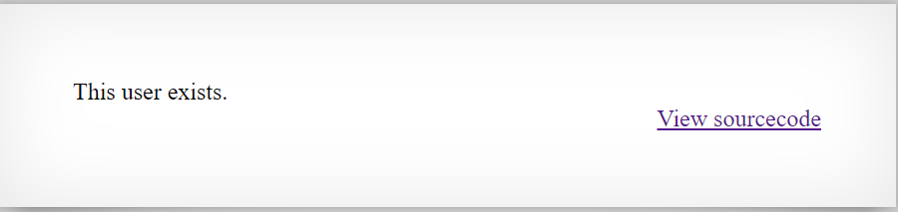

Step 4:SQL injection

Then I tried to execute queries to determine what is the pass with the SQL command **LIKE**

With program that run all over the digits and ascii characters and create the password properly with post requests in python.

Program: Level15.py

